Chapter 8 — Functions (Python Notes)

What Is a Function?
- A function is a named block of code that does one specific job.
- Functions help you:
  - Avoid repeating code
  - Make programs easier to read
  - Test and fix code more easily
- You define a function once and call it whenever you need it.

Defining a Function
- def → keyword to define a function
- Function name → greet_user
- Parentheses () → hold parameters (even if empty)
- Colon : → starts the function body
- Indented code → function body
- Docstring (""" """) → explains what the function does

Calling a Function
greet_user()
- Runs the code inside the function

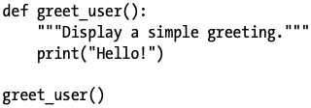

Passing Information to a Function
- Functions can accept parameters
- You pass arguments when calling the function

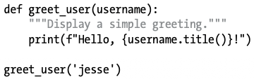

Parameters vs Arguments
- Parameter → variable in the function definition
def greet_user(username):
- Argument → actual value passed to the function
greet_user('jesse')

Positional Arguments
- Arguments matched by order
- ⚠️ Order matters:
describe_pet('harry', 'hamster') # Wrong meaning

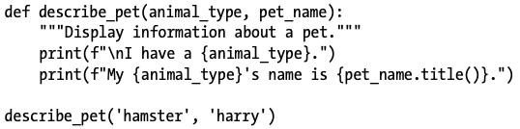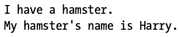

Keyword Arguments
- Use parameter=value
- Order does not matter
- ✔️ Clear and safer than positional arguments
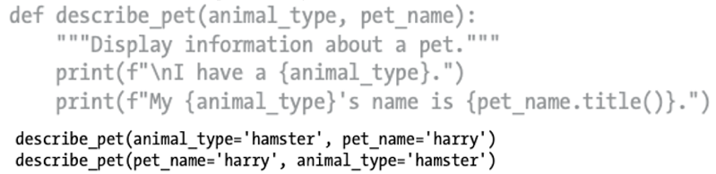

Default Values
- Provide a default for a parameter
- If no value is passed, Python uses the default
- Parameters with defaults must come last

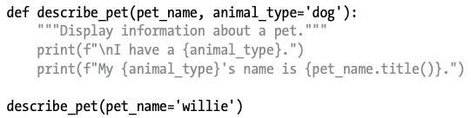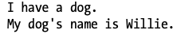

-- Same Output

⚠️ Defining an argument within the function definition, the new argument will override the default value
-- Different Output

Equivalent Function Calls
Because positional arguments, keyword arguments, and default values can all be used together, often you’ll have several equivalent ways to call a function.
describe_pet('willie')
describe_pet(pet_name='willie')
describe_pet('harry', 'hamster')
describe_pet(pet_name='harry', animal_type='hamster')
Avoiding Argument Errors
- Errors happen when:
  - Too few arguments
  - Too many arguments
- Python error messages tell you:
  - Which arguments are missing
  - Where the problem occurred
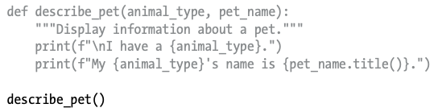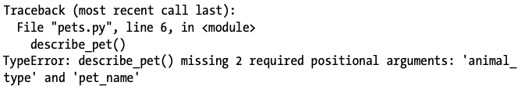

Returning Values
- Functions can return data, not just print

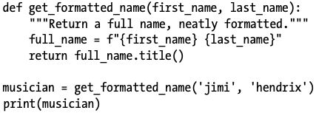

- This might seem like a lot of work to get a neatly formatted name when we could have just written:
- 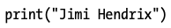
- But when you consider working with a large program that needs to store many first and last names separately, functions like get_formatted_name() become very useful.

Optional Arguments
- Use default values to make arguments optional

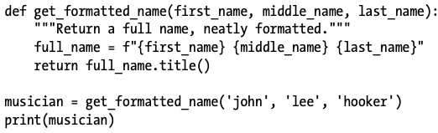

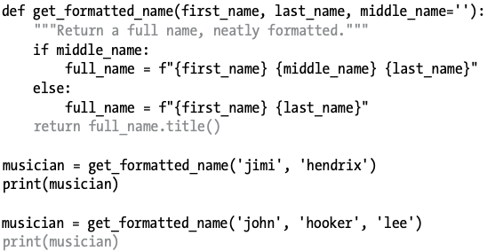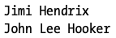
Returning Dictionaries
A function can return any kind of value you need it to, including more complicated data structures like lists and dictionaries.

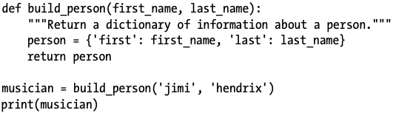

- None = no value
- None evaluates to False in conditions

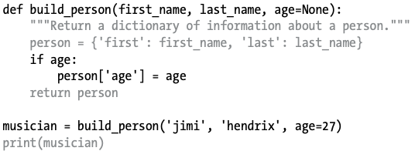

Functions with while Loops
You can use functions with all the Python structures you’ve learned about so far. For example, let’s use the get_formatted_name() function with a while loop to greet users more formally.
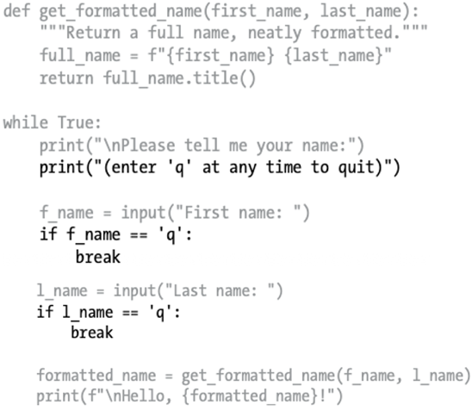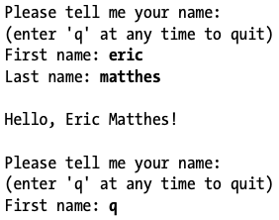

Passing a List to a Function

Sometimes you won’t know ahead of time how many arguments a function needs to accept. Fortunately, Python allows a function to collect an arbitrary number of arguments from the calling statement.
For example, consider a function that builds a pizza. It needs to accept a number of toppings, but you can’t know ahead of time how many toppings a person will want. The function in the following example has one parameter, *toppings, but this parameter collects as many arguments as the calling
line provides:

The asterisk in the parameter name *toppings tells Python to make an empty tuple called toppings and pack whatever values it receives into this tuple.
*args collects arguments into a tuple

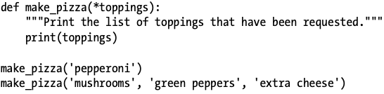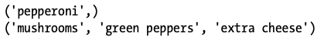

Now we can replace the print() call with a loop that runs through the list of toppings and describes the pizza being ordered:

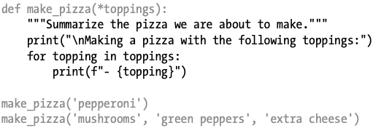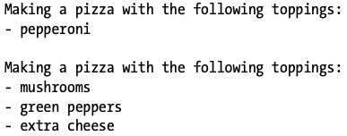

Modifying Lists in Functions
- Changes to a list inside a function are permanent
- To prevent changes, pass a copy
function_name(list_name[:])

Mixing Positional + Arbitrary Arguments
If you want a function to accept several different kinds of arguments, the parameter that accepts an arbitrary number of arguments must be placed last in the function definition. Python matches positional and keyword arguments first and then collects any remaining arguments in the final parameter.

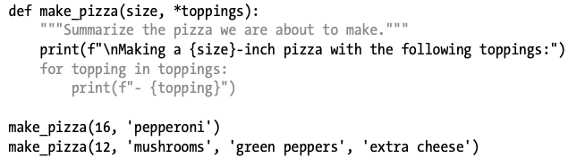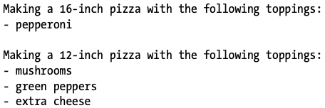

Arbitrary Keyword Arguments (**kwargs)
Sometimes you’ll want to accept an arbitrary number of arguments, but you won’t know ahead of time what kind of information will be passed to the function. In this case, you can write functions that accept as many key-value pairs as the calling statement provides.
**kwargs collects extra keyword arguments into a dictionary

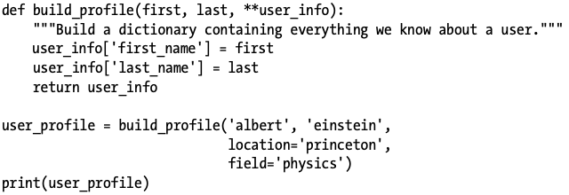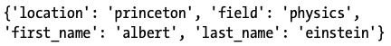

Storing Functions in Modules
- A module is a .py file with functions
- Benefits:
  - Cleaner main program
  - Reusable code
  - Collaboration
There are several ways to import a module, and I’ll show you each of these briefly:

Importing an Entire Module

This first approach to importing, in which you simply write import followed by the name of the module, makes every function from the module available in your program. If you use this kind of import statement to import an entire module named module_name.py, each function in the module is available through the following syntax:

- Create a file for the module
pizza.py
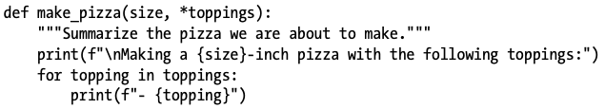
- Create a file for the actual program
maing_pizza.py
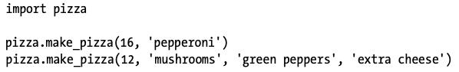 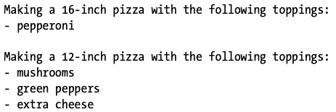

Importing Specific Functions

You can also import a specific function from a module. Here’s the general syntax for this approach:

You can import as many functions as you want from a module by separating each function’s name with a comma:

The making_pizzas.py example would look like this if we want to import just the function we’re going to use:
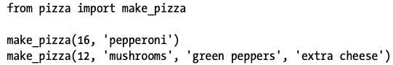

With this syntax, you don’t need to use the dot notation when you call a function. Because we’ve explicitly imported the function make_pizza() in the import statement, we can call it by name when we use the function.

Using “as” to Give a Function an Alias
The general syntax for providing an alias is:

If the name of a function you’re importing might conflict with an existing name in your program or if the function name is long, you can use a short, unique alias an alternate name similar to a nickname for the function. You’ll give the function this special nickname when you import the function.

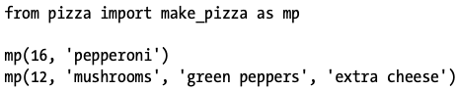

Using as to Give a Module an Alias
The general syntax for this approach is:

You can also provide an alias for a module name. Giving a module a short alias, like p for pizza, allows you to call the module’s functions more quickly. Calling p.make_pizza() is more concise than calling pizza.make_pizza():

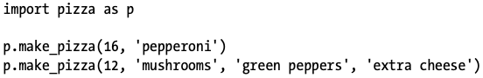

Importing All Functions in a Module
You can tell Python to import every function in a module by using the asterisk (*) operator:

⚠️ The best approach is to import the function or functions you want or import the entire module and use the dot notation. This leads to clear code that’s easy to read and understand. I include this section so you’ll recognize import statements like the following when you see them in other people’s code

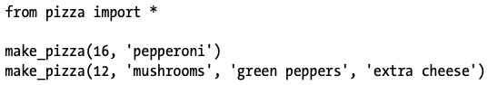

Styling Functions (PEP 8)
- Use lowercase + underscores for names
- Every function should have a docstring
- Default values: no spaces around =
def func(x, y=10):
- Max line length: 79 characters
- Separate functions with 2 blank lines
- Imports go at the top of the file

Why Functions Matter
- Write code once, reuse many times
- Easier to:
  - Read
  - Debug
  - Test
  - Maintain
- Well-named functions explain what a program does

